**Recommendations:**

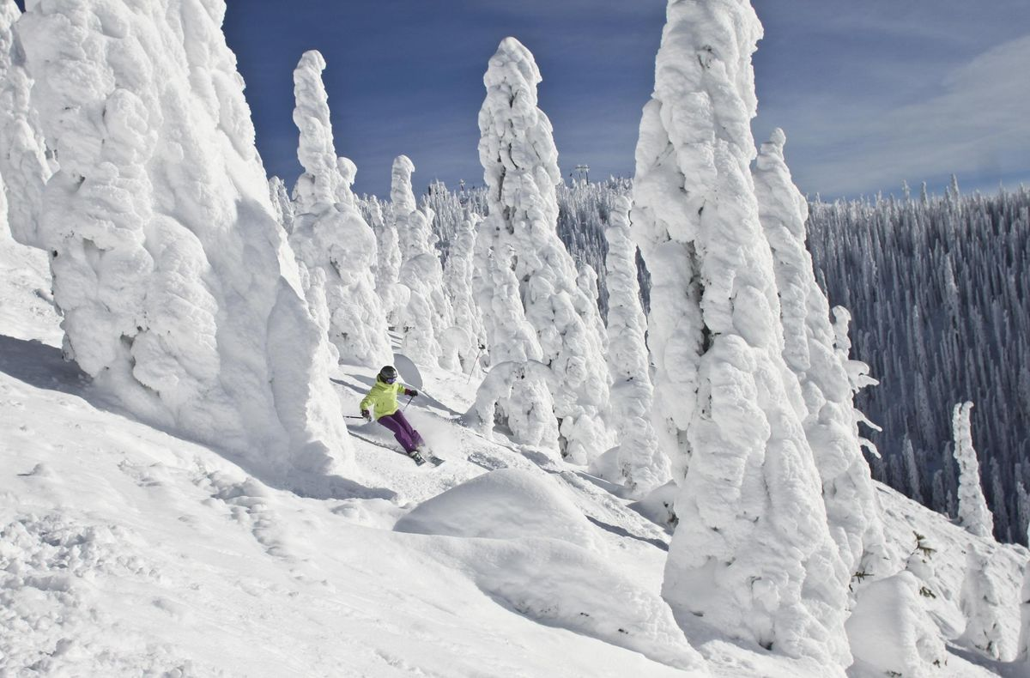

* Our Model suggests that Mountain Resort’s ticket price is lower than the predicted model by 16.31%, and the resort have many potential scenarios for either cutting costs by closing runs or increasing ticket price by increasing vertical drop, adding acres snow making or increasing the longest run.
* Increasing the vertical drop by 150 ft would increase the ticket price by 10.44% from $81 to $89.46, resulting in revenue increase by $14,811,594.
* Adding 2 acres of snow making would increase the ticket price by 12% from $81 to $90.75, resulting in revenue increase by $17,068,841.
* When it comes to closing 10 used Runs, our Model predicted the following:
  + Closing one run will have no impact on Ticket price or revenue.
  + Closing 2 runs reduce support for ticket price and so revenue by $0.4 and $750,000 respectively.
  + Closing 3 runs, it seems they may as well close 4 or 5 as there’s same loss in ticket price and revenue by $0.67 and $1.250M respectively.
  + Closing 10 runs reduce support for ticket price and so revenue by $1.71 and $3M respectively.
  + Because we don’t know the operating cost per used run, we can’t determine how much cost saving will be offset the loss in revenue after closing more than one run.

